<https://translate.googleusercontent.com/translate_c?act=url&depth=1&hl=en&ie=UTF8&prev=_t&rurl=translate.google.com&sl=auto&tl=en&u=http://www.hardcopyworld.com/gnuboard5/bbs/board.php%3Fbo_table%3Dproject_hardcopy%26wr_id%3D164&usg=ALkJrhg6mX5s_KfmKFW-v3hg5vMZfLiGuQ>

<https://translate.google.com/translate?sl=auto&tl=en&js=y&prev=_t&hl=en&ie=UTF-8&u=http%3A%2F%2Fwww.hardcopyworld.com%2Fgamemaker.html&edit-text=&act=url>

Games:

<https://translate.googleusercontent.com/translate_c?act=url&depth=1&hl=en&ie=UTF8&prev=_t&rurl=translate.google.com&sl=auto&tl=en&u=http://www.hardcopyworld.com/gnuboard5/bbs/board.php%3Fbo_table%3Dgame_title&usg=ALkJrhg5vV9EU7VcES5nMuSa5kZZjBdXUA>

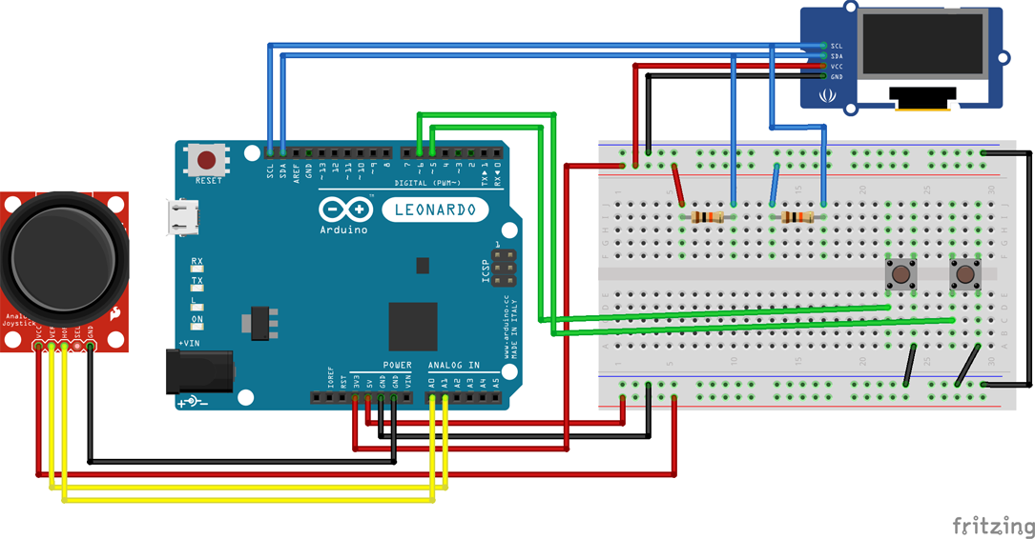

Starts off with a little history of game systems made with the Arduino,

and goes into setup and programming for the Game Maker

<https://github.com/godstale/game-maker>